**Database and file Management Systems** (CIS 2109)

**Lab 6**

1. **(1) Reference Chapters 2 and 3 in "Modern Database Management"**
2. **Use the following link as an example of how to use oracle data modeler:**

[**https://www.youtube.com/watch?v=yu2Yr_GFC1E**](https://www.youtube.com/watch?v=yu2Yr_GFC1E)

**Deliverables:**

Upload on blackboard one Word document report including screenshots of all of the E-R diagrams. You also need to upload a zip file with your models (see step 6 on how to save your models).

**Lab Description:**

For each of the descriptions below and using **Oracle SQL Developer Data modeler**, express the relationships in each description graphically with an E-R diagram. In order to start using it follow these steps:

1. Go to View -> Data Modeler -> and click on Browser

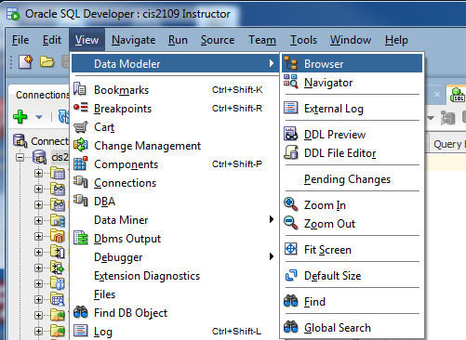

1. Then a new Browser opens for the Data Modeler:

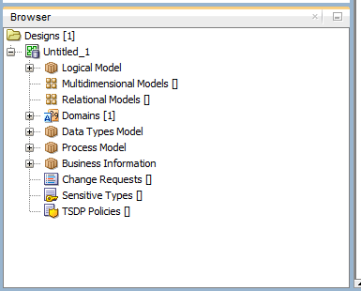

1. Now Go to Logical Model and right click. In the new window select Show:

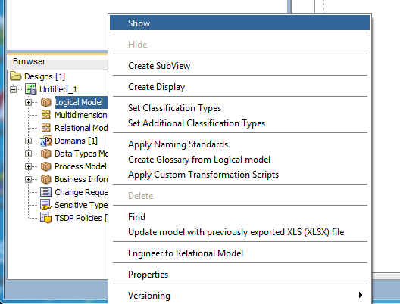

1. A new tab opens, where you can design your ER diagram. For instructions follow the link at the beginning of the document.
2. Notice that if you want to save your work at the end of the lab you will have to go to:

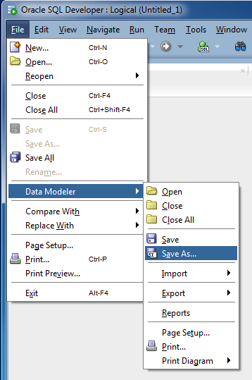

1. **Also, once you save you can work on it from home only if you copy both the .dml file and the folder (with the same name as the .dml file) that is created**. For example:

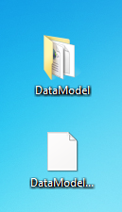

**Part 01**

1. A piano manufacturer wants to keep track of all the pianos it makes individually. Each piano has an identifying serial number and a manufacturing completion date. Each instrument represents exactly one piano model, all of which have an identification number and a name. In addition, the company wants to maintain information about the designer of the model. Over time, the company often manufactures thousands of pianos of a certain model, and the model design is specified before any single piano exists.
2. A piano manufacturer employs piano technicians who are responsible for inspecting the ­instruments before they are shipped to the customers. Each piano is inspected by at least two technicians (identified by their employee number). For each separate inspection, the company needs to record its date and a quality ­evaluation grade.
3. The piano technicians have a hierarchy of ­reporting relationships: Some of them have supervisory responsibilities in addition to their inspection role and have multiple other technicians report to them. The supervisors themselves report to the chief technician of the company.

**Part 02**

1. A vendor builds multiple types of tablet computers. Each has a type identification number and a name. The key specifications for each type include amount of storage space and display type. The company uses multiple processor types, exactly one of which is used for a specific tablet computer type; obviously, the same processor can be used in multiple types of tablets. Each processor has a manufacturer and a manufacturer’s unique code that identifies it.
2. Each individual tablet computer manufactured by the vendor (see 2h) is identified by the type identification number and a serial number that is unique within the type identification. The vendor wants to maintain information about when each tablet is shipped to a customer.
3. Each of the tablet computer types (see 2h) has a specific operating system. Each technician the company employs is certified to assemble a specific tablet type–operating system combination. The validity of a certification starts on the day the employee passes a certification examination for the combination, and the certification is valid for a specific period of time that varies depending on tablet type–operating system combination.

**Part 03**

1. An Artist Management company would like to store information about artists. Artists are identified by an Id and are described by their Name, Age and Gender. Most of the artists are under contract with the company and for them the company stores multiple Samples of their work. There are however also interested in tracking prospective artists, for whom they have no sample of their work but they may have recommendations about them from different sources.
2. There are a lot of sources that hint the company about prospective artists. These sources are identified by an Id and they may also have a name, description (critic or newspaper article or local performance stage) and a Quality index which is an attribute that describes the quality of the information that this source has provided in the past. Each source is making any number of recommendations about prospective artists and every prospective artist may be recommended by any number of sources.
3. Now update the previous diagram to take into account that for each recommendation the company needs to store a summary, a quality evaluation from the source for the prospective artist and the date that the recommendation was received. Notice that every recommendation that comes from one source can be a recommendation for more than one prospective artists (as they may be a group).
4. The company would also like to store information about News Items that are published for each of the artists. These Items are identified by an Id are described by the source of the news and the content. Every news item is for one of more artists of the company, while each artist may have any number (even zero) of news items associated with him.